Strains in the Vertebral Arteries
With Movements in the Upper Cervical Spine

Thomas Langer

Introduction
The vertebral arteries are particularly vulnerable to injury with rapid head and neck movements and the segment that is particularly vulnerable is the segment between the transverse processes of the axis and the atlas (Bladin and Merory 1975; Norris, Beletsky et al. 2000). Presumably, the reason for the disproportionately great vulnerability at this level is the unusually large range of motion in the atlanto-axial joint (Kapandji 1974; Levangie and Norkin 2001). While estimates vary, it is thought that about half of the lateral rotation in the cervical spine occurs in the C1/C2 segment, which for most individuals means that 45° or more of lateral rotation is well within the possible range of motion for that joint. It may be proportionately, and possibly absolutely, greater in individuals that have stiffness in the lower cervical spine with compensatory changes. Sixty degrees is probably an absolute maximum, because the vertebral arches are beginning to impinge upon the spinal cord with rotations of that magnitude.
This paper builds upon a model of upper cervical neck movements that has been introduced elsewhere (Langer 2004), to examine the strains in the vertebral arteries with lateral rotation in the atlanto-axial joint. It is the first part of a two-part study principally concerned with how strains in the vertebral artery affect the flow of blood through the arteries (Langer, Arnold et al. 2004).
While it is difficult to directly monitor the changes in conformation in the vertebral arteries in a neck that is being rotated into endrange positions, it is comparatively easy to monitor the blood flow with Doppler ultrasound. That technique can measure blood velocity continuously in the vertebral arteries, even when the head and neck are being mobilized into an array of endrange positions. In a study of the changes in blood flow when the head and neck were placed in stress positions normally used to test for the competence of the vertebro-basilar circulation to the brainstem, cerebellum, and posterior cerebral hemispheres it was found that most the stress positions were not particularly stressful (Arnold, et al. 2004). By far the most stressful position for the vertebral arteries was a pre-manipulative hold for an atlanto-axial manipulation. In that position, the neck is sideflexed to one side and the atlas is laterally rotated upon the axis so that it rotates away from the side of the sideflexion. To casual inspection, the premanipulative hold appears the least stressful position for the neck and the vertebral arteries. However, it reduces blood flow in a majority of individuals and will often completely occlude the vertebral artery for at least a part of the pulse cycle, when the rotation is to the side contralateral to the monitored artery. The artery ipsilateral to the direction of rotation will frequently have a demonstrable increase in blood flow.
These observations prompted questions as to the causes of the reduced blood flow. What is it about the movements in certain directions that stress the artery, while movements that are even more aggressive are much less stressful? To address these questions it was necessary to look carefully at what the bones in the upper cervical spine were doing during these movements and how those movements might strain the vertebral arteries. To that end, a model was constructed that allows one to compute the alignments of the vertebrae and the occiput for any specific set of movements in the joints of the region (Langer 2004). Starting with that model, the strains imposed upon the C1/C2 section of the vertebral artery were examined.

Strain In the Vertebral Arteries at Various Levels of the Neck
As with most arteries which cross joints, the vertebral arteries are distributed so that they run close to the axes of rotation for the vertebrae of the neck. The vertebral arteries run through the transverse foraminae of the cervical vertebrae (Kapandji 1974; White and Panjabi 1978; Williams, Bannister et al. 1995), which lie directly lateral to their vertebral bodies. By doing so, the strain in the artery is minimized. However, the nature and magnitude of the strains placed upon the vertebral artery vary considerably, depending upon the level examined. In particular, the joints between the atlas and the axis place far more strain upon the vertebral arteries than any other cervical level.
The Lower Cervical Spine: In the lower cervical spine (C3 through T1), the axes of rotation for the various normal motions of the cervical vertebrae are directed through their vertebral bodies (Kapandji 1974), therefore the amount of stretching and/or twisting of the arteries is small. In addition, the intervertebral joints normally allow only small movements, on the order of ten degrees or less. Consequently, there is comparatively little strain in most segments of the vertebral artery.
The Atlanto-occipital Joint: As the vertebral artery passes through the transverse foramina of the atlas, it lies immediately lateral to the articular facets of the atlanto-occipital joint and wraps around the posterior aspect of the facet joint as it penetrates the atlanto-occipital membrane (Williams, Bannister et al. 1995). Once inside the vertebral canal the vertebral arteries ascend on the medial aspect of the articulation and converge in the floor of the posterior fossa, at the pontomedullary junction, to form the basilar artery. The proximity of the vertebral arteries to the atlanto-occipital facets as they cross the joint ensures that there is little distortion of the arteries by normal head movements. The greatest strain would be expected to occur in endrange extension. There may be some traction when the head is fully extended, because the clivus at the base of the occiput is moved away from the posterior aspect of the atlanto-occipital facets, where the artery is attached to the atlanto-occipital membrane and the atlas. Generally, there is little opportunity for traction or twisting of the vertebral arteries distal to the transverse foramina of the atlas.
The Atlanto-axial Joint: The last segment of the vertebral artery to be considered is the segment between the transverse foramina of the axis and the transverse foramina of the atlas, the C1/C2 segment. There is considerable movement in the atlanto-axial joint (~ 90° of lateral rotation, 45° to each side of the midline) and the axis of rotation is vertically through the odontoid process, which is a substantial distance medial to the course of the artery between the transverse foraminae. The transverse foraminae of the atlas and axis are more anteriorly placed than at other cervical levels, so the strain due to anterior/posterior location is less than it might be with a more posterior transverse process. The result of the vertebral artery’s location is that it is subjected to considerable twisting and shearing stresses when the joint is near endrange in either direction.
Immediately prior to this segment and immediately after the segment the vertebral artery goes through two right angle changes in direction which may act to tether its ends. To mitigate this huge range of motion and potential tethering, the vertebral artery is usually observed to have some spare length in the C1/C2 segment when viewed in angiograms. However, the amount of play in this segment is highly variable between individuals, ranging from an artery that passes almost directly between the two flexures to arteries that have a prominent laxity.
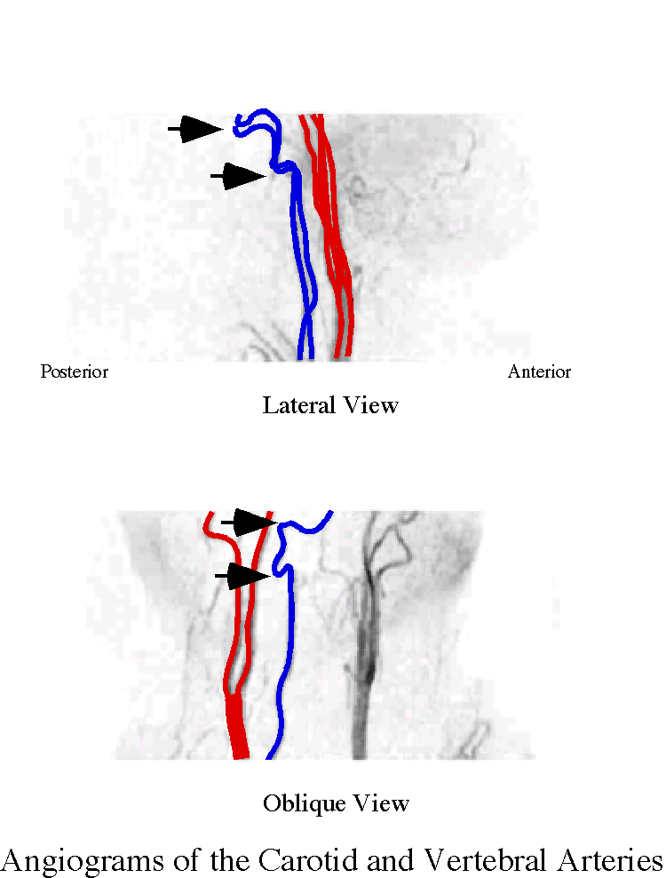
Figure 1. An angiogram of the vertebral and carotid arteries, showing the atlanto-axial segment. Note that the vertebral arteries experience two abrupt changes in direction as they pass though that region (between arrows). The red vessels are the carotid arteries.
It has been observed that nearly all cases of vertebro-basilar cerebrovascular accidents associated with rapid head movements occur in the segment of the vertebral artery between the atlas and the axis (Bladin and Merory 1975; Norris, Beletsky et al. 2000). Consequently, it behooves us to look carefully at the anatomy of this region of the vertebral arteries and the cervical spine and sort out the distortions that the vertebral arteries experience with normal and abnormal head and neck movements.

Methods
The calculations start with the movements of the upper cervical spine. The basis for those calculations is a model described in detail elsewhere (Langer 2004). The model uses quaternions to express the rotations of each bony element, which is represented by an array of vectors, called a framed vector. Quaternion analysis is an excellent means of modeling rotations of rigid bodies, because they incorporate in their formalism all the attributes of such rotations (Hamilton and Joly 1869; Hardy 1881; Joly 1905; Kuipers 1999). Framed vectors were developed to codify the location, extension, and orientation of an orientable object so that quaternions could be used efficiently to compute the transformations produced by their rotation.
In this paper, the axis vertebra is taken as fixed and the principal rotation is in the atlanto-axial joint. Normally, there are no movements in the atlanto-occipital joint, but some trials were run with movements in that joint. The implications of concurrent rotations in both joints are explored in another paper. Movements in that joint do affect rotation in the atlanto-axial joint, but mostly in restricting its excursion.
Unless stated otherwise, the only movement used in the atlanto-axial joint was about a longitudinal axis through the odontoid process. The main feature extracted from the model, for this analysis, was the locations of the transverse foraminae. For the purposes of the model, it is generally assumed that the vertebral arteries run directly from the transverse foramina of the axis to the transverse foramina of the atlas. It is known that there is often a greater or lesser looping of the arteries in this space, but it is not feasible to choose an particular amount of excess since the amount varies considerably from individual to individual (Williams, Bannister et al. 1995). By assuming none we can see the implications of the strains most easily and then can look at how the degree of slack will affect the basic observations. The slack may well be the anatomical attribute that most differentiates one individual’s response to neck mobilization from another’s, but, unfortunately, it is not readily available for measurement.
Data is taken from many sources, most of which do not have calibrations, therefore it has been convenient to express all measurements in a unit that can generally be deduced from the images. The unit of measure is based upon the distance between the anterior and posterior tubercles of the atlas. The distance between those two points is set at two units and every other measurement is expressed as a multiple of that distance. Measurements of actual vertebrae and calibrated images indicate that one unit is approximately equal to 20 to 25 millimeters. The center of the vertebral canal is about equidistant from those two landmarks, therefore it is taken as the center of the coordinate system.
All the modeling described in the results was done with programs written in Mathematica, Version 4. Most of the figures were generated in that program as well.

Results

The Movements of the Atlanto-axial Joint
The atlanto-axial joint is composed of two bones, the atlas and the axis, which articulate in four interfaces. The median joint is, first, between the anterior surface of the odontoid process and the posterior surface of the anterior arch of the atlas, and, second, between the posterior surface of the odontoid process and the transverse ligament that extends between the two lateral masses of the atlas. Laterally, the inferior articular facets of the atlas rest upon the superior articular facets of the axis. The bony foundations of these articular surfaces are barrel-shaped so as to be convex in the sagittal plane and concave in the coronal plane. The curvatures are quite gentle, and it is thought that the articular cartilages compensate by filling out the curves so the main action of the lateral articular joints is to act as a nearly flat surface for the atlas to glide upon as it rotates about the odontoid process. In addition, the lateral facets slope inferiorly, so that the inferior and superior faces of the joints are segments of two interlocked cones. Therefore, movement in the lateral joints is like a funnel moving upon a similar funnel placed inside it. The spouts of the two funnels would be aligned with the dens.
There may be about 3-4 millimeters of approximation between the atlas and the axis as they reach the extreme of lateral rotation. This small movement is probably not important in reducing the strain on the vertebral artery, because it occurs when the artery is already fairly oblique. Given the other uncertainties in the modeling process, this approximation of the two vertebrae is a minor issue. Trial calculations indicate that it has little effect on the strains in the vertebral arteries.

C1/C2 Gap: The Distance between the Foraminae
The transverse foraminae for the axis and atlas are located between the center of the odontoid process and the center of the vertebral canal along an anterior-posterior axis at about 0.37 units anterior to the mid-coronal plane (Figure 2). The foraminae in both bones are in the same coronal plane. However, they are in different sagittal planes; the hole for the atlas lies 1.2 units lateral and that for the axis, 1.0 units lateral. These observations allow one to write down the descriptions for the two foraminae.
$$\begin{aligned}\text{atlasHole}=\left\{0\text{.}\text{37}∗r,1\text{.}2∗s,0\text{.}\text{25}∗t\right\} \\ \text{axisHole}=\left\{0\text{.}\text{37}∗r,1\text{.}0∗s,−0\text{.}5∗t\right\}\end{aligned}$$
This means that in neutral position the distance between the holes is the difference between these two vectors or 0.776 units. As the atlas rotates upon the axis, it will increase the distance between the holes as the artery is sheared between the two transverse processes (Figure 3.)

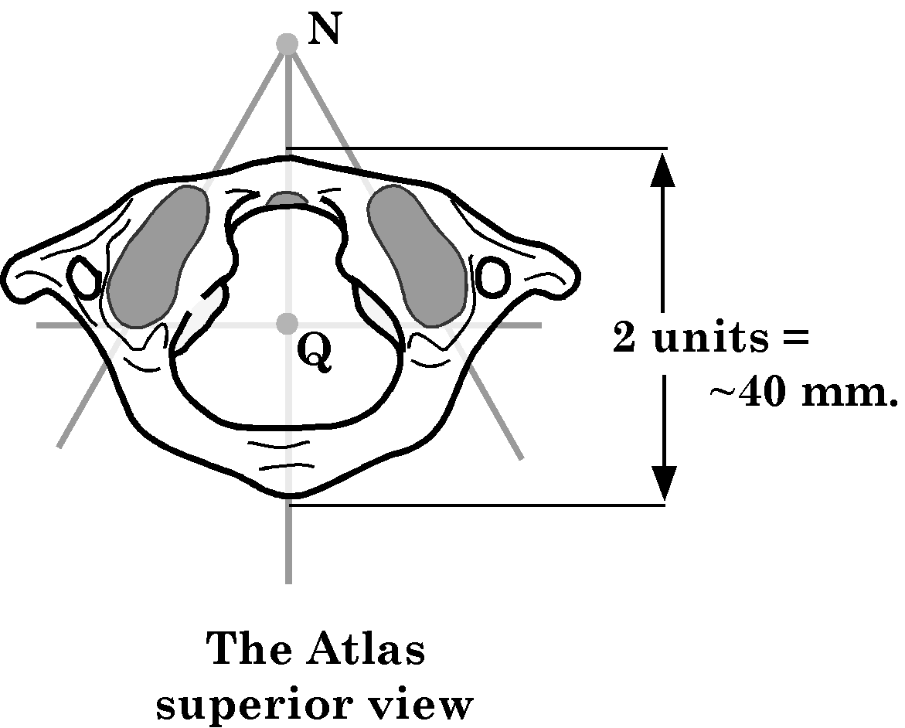
Figure 2. A drawing of the superior aspect of the atlas with the scale indicated. The transverse foraminae are located just lateral to the articular surfaces of the lateral atlantoaxial joint.
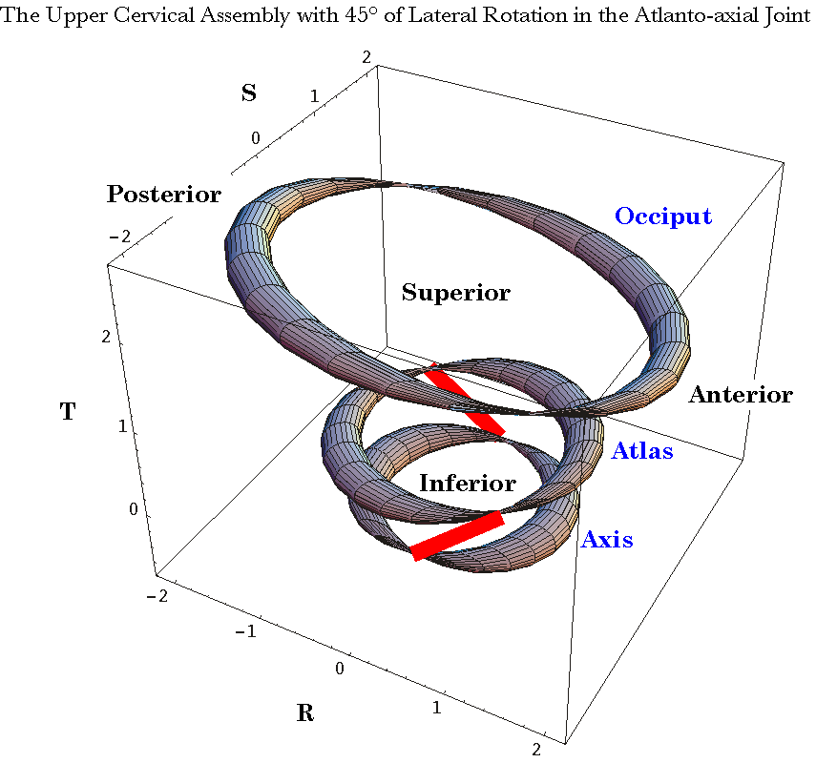
Figure 3. The alignments of the vertebrae with the orientations of the vertebral arteries (red) indicated. The atlas, axis, and occiput are represented by rings. The pinched parts of the atlas and axis rings lie at the locations of the transverse foraminae. The vertebral arteries are indicated by the red bars. In this instance, the atlas has rotated 45° to the left upon the axis.
While the normal estimate of the maximal ROM is 45°, the length of the gap between the two foraminae has been computed by rotating the atlas upon the axis for angular excursions from –50° to +50°. Negative excursions are towards the contralateral side and positive excursions are ipsilateral rotations. The distribution of gap length divided by the gap length in neutral is plotted in Figure 4. The distribution is nearly constant for the first few degrees and then it curves up in both directions. Note that there is initially a slight reduction of the gap length as the atlas starts to turn contralaterally. The distance increases almost linearly once the rotation exceeds about 20° to either side of the minimal length. As the rotation approaches 45°, the length of the gap approaches 1.5 to 1.6 times its length in neutral position.

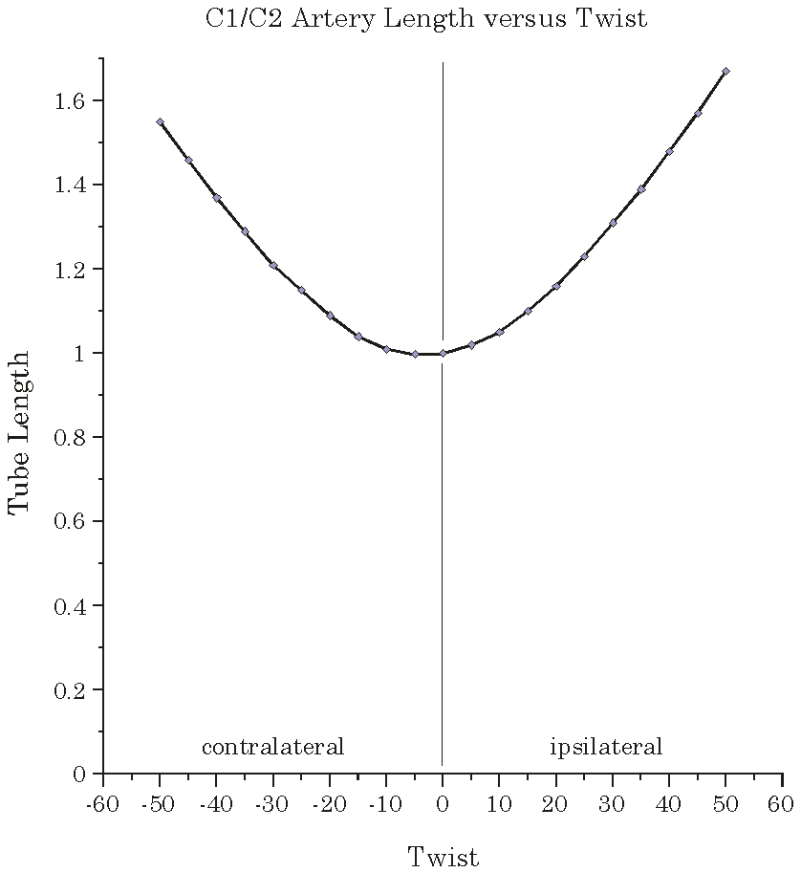
Figure 4. The distribution of the gap magnitude versus rotation. The gap between the two transverse foraminae is minimal for a slight contralateral rotation and it increases approximately linearly with rotation, once the rotation is more than about 20°.
The variable that is computed is the distance between the two foraminae. In some individuals the vertebral artery passes directly from one foramina to the other, therefore gap length is a good approximation to the artery length in the C1/C2 interval. Many individuals have a greater or lesser amount of slack in the vertebral artery as it passes between the two transverse processes, therefore the vertebral artery length exceeds the minimal length of the gap and it does not change until the gap length equals the artery length, when its arterial length starts to follow the distribution of gap length. Consequently, gap length is most apt to be a good estimate of arterial length as the amount of lateral rotation increases. As it happens, we are most concerned with the strains in the vertebral artery as lateral rotation approaches its endrange.
For brevity and specificity of meaning, let the length of the gap be symbolized by $L_{G}$ and the arterial length in neutral position be symbolized by$L_{\text{AN}}$. Arterial length in general will be$L_{A}$. This analysis is most concerned with those situations when
$$L_{A}=L_{G}³L_{\text{AN}}\text{.}$$

Computation of a Tube: Torsion and Shear in a Tube
In much of the following analysis, it will be assumed that we are dealing with an elastic tube that is fixed at both ends to the foramina through which it is passing and that as it passes through the foramina it is circular in cross-section, unless stated otherwise. It is assumed that the wall of the stretched artery will try to minimize the distance between the points of attachment. Therefore, if point $A$ is connected to point $A^{'}$ when the arterial length first equals the gap length, then they will remain connected and the strip of the wall between them will remain straight, unless displaced by some external force. Let that position where the artery first becomes taut, but .not stretched be the taut point. There will actually be two taut points, because there is one for ipsilateral rotation and another for contralateral rotation. For all rotations that lie beyond the taut points, the artery is in the taut interval.

Torsion and Shear in a Tube
The vertebral artery between the transverse processes of the axis and the atlas is a tube that experiences shear as the transverse processes rotate relative to each other, causing the artery to be elongated. It also experiences torsion due to the rotation of one end of the artery relative to the other. The combined effect is a twisting of the artery. Both of these distortions will affect the rate of flow through a distorted tube.
Shear will cause the transverse cross-section of the tube to become flattened, so that if the tube is circular in cross-section when it is in neutral position, it will become elliptical in cross-section when it is sheared. Since the rate of flow through the tube increases with distance from the wall of the tube, flattening of the tube will decrease flow through the tube. This relationship will be considered in detail elsewhere (Langer 2004).
Torsion is different in that it tends to pinch the middle of the tube. This can be seen by considering a circular tube that has lines extending from one end to the other, parallel with the long axis of the tube. Now, consider what happens as the upper end of the tube is rotated 180° relative to the lower end, about the longitudinal axis of the tube. Each of the lines passes through a point midway between the ends of the tube and centered on the longitudinal axis of the previous configuration. The tube is pinched shut by the twisting of the tube. For lesser amounts of torsion there is a narrowing of the tube that is most pronounced in the middle portion of the tube.
Naturally, both of these distortions can happen at the same time. In fact, if the axis of rotation is not the longitudinal axis of the tube, then both types of distortion will be compelled to occur as a result of the geometry of the situation.
There is a third type of distortion that may occur. If the distal end of the tube is rotated about an axis that is not parallel with the longitudinal axis of the tube the one side of the tube will be relatively stretched and the opposite side will be relatively relaxed. This is another form of shear that is not necessarily due to the shearing of the tube as a whole. It may increase or decrease the flow. For instance, if it occurs in the opposite direction to the transverse shear, then it may reverse the flattening that would occur otherwise.
To model the vertebral artery, let us initially assume that the artery is circular as it passes through the transverse foraminae. Therefore, we define an array of points that represent the circumference of the artery. The offset between the two ends is taken to be the vector between the transverse foraminae for the axis and atlas. The artery is assumed to have a radius of 0.1 unit. The actual radius of a vertebral artery is irrelevant to what follows, because the flows are expressed as fractions of the flow in a straight circular tube with a unit radius.

The Vector Representation
The vessel's walls are represented by a set of vectors that extend from the ring at the transverse foramina of the axis to the corresponding part of the ring in the transverse foramina of the atlas.
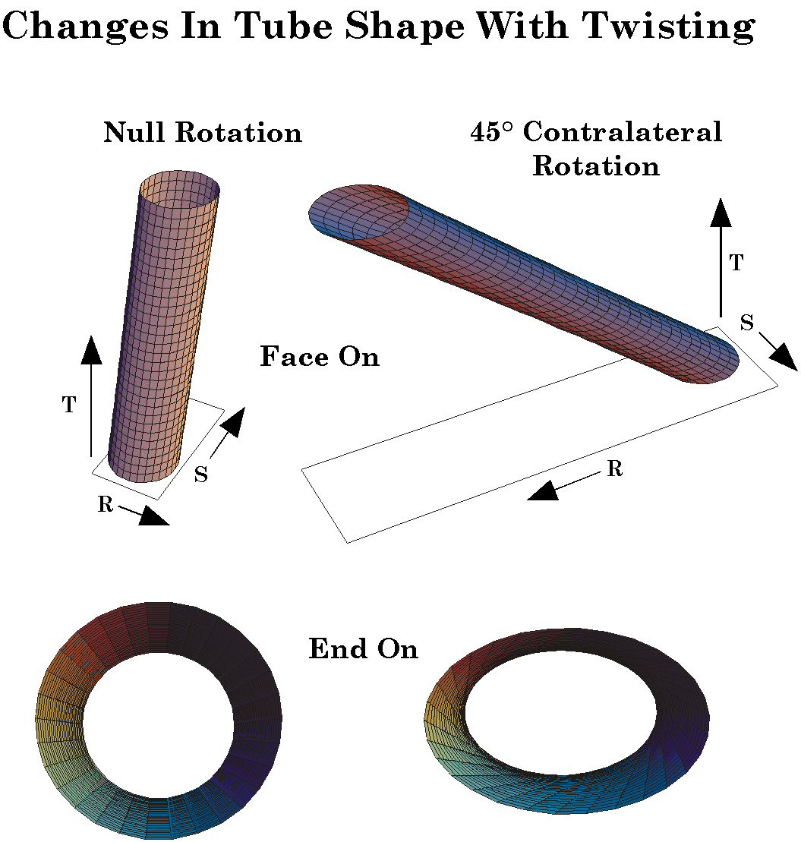
Figure 5. The configuration of a tube in neutral position and 45° of ipsilateral rotation. Lateral and end-on views. Rotation of one end of a tube about an eccentric axis of rotation will cause the tube to become flattened, rotated, and pinched. This combination will called twisted.
The model computes an array of 36 points on the circular cross-sections of the tube as it passes through the foraminae. The axis is the foundation of the assembly in that all rotations are taken as occurring relative to it. The ring at the foramina of the atlas is rotated about the longitudinal axis of the odontoid process. The new location of the center and the new orientation of the distal ring are computed and vectors are drawn from points on the proximal ring to the corresponding points on the distal ring.
The image is rendered as a three-dimensional plot that can be manipulated to view it from different angles. Sample calculations are represented in Figure 5. Two tubes are represented, each from two perspectives. The first tube is the tube for neutral position. From an anteromedial perspective, the tube is seen to be sheared laterally, but otherwise unremarkable. The lateral shear is due to the transverse foramina for the atlas lying approximately 1.2 units lateral and that for the axis lying about 1.0 units lateral. When viewed end-on from the atlas end, it is just perceptible that the cross-section is not quite circular. The second tube is the situation when the atlas has been rotated 45° ipsilaterally. The tube is clearly stretched and pinched in its middle section. When viewed end-on, the flattening is also quite apparent. These distortions of the originally circular tube will have implications for the flow of fluid through the tube. How the flattening and pinching of the tube affects fluid flow is highly non-linear and complex. Most of the accompanying paper (Langer, 2004) deals with this phenomenon.

The Flattening and Pinching of the Tube
Before looking at flow through elliptical tubes of varying cross-sectional area and eccentricity, it is necessary to compute what those cross-sections are. The circumferential lines in the illustrations in Figure 5 are horizontal cross-sections of the tube, taken at 30 intermediate levels between the two ends. They do not correspond to the arterial cross-sections that the blood would see as it flows along the tube. Those cross-sections would be transverse or perpendicular to the longitudinal axis of the tube. The transverse cross-sections must be computed for analyzing blood flow.
In the computer, tubes like those in Figure 5 were rotated and sliced perpendicular to the longitudinal axis of the vessel. For each of 30 equally spaced cross-sections through a tube that had been sheared and pinched by rotation about the odontoid process, we computed the cross-section and, from that, the major and minor axes of the elliptical cross-section and its eccentricity. Eccentricity of a ellipse is defined as follows. If the major axis is 2a and the minor axis is 2b, then the eccentricity is $e=\sqrt{a^{2}−b^{2}}/a$. For a circle, $e=0\text{.}0$.
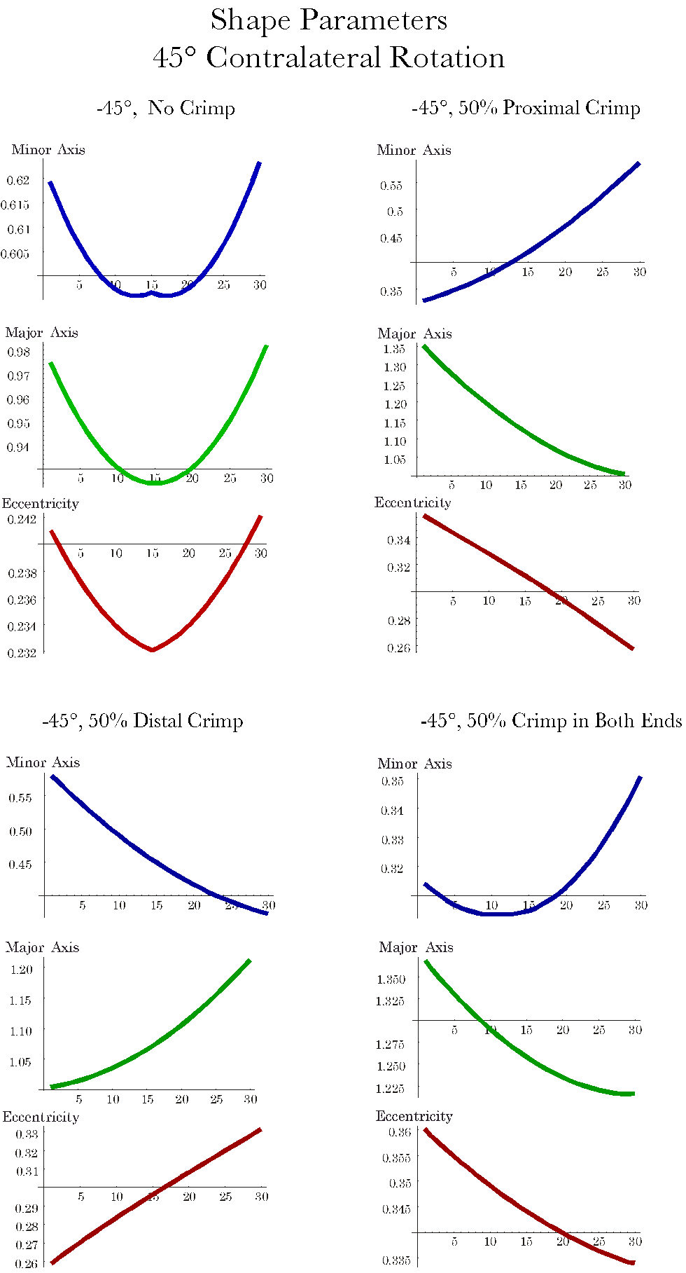
Figure 6. Profiles of anatomical attributes of twisted tubes. The distributions of the major and minor axis and the eccentricity of twisted tubes like those in Figure 5 are computed for a tube with no crimp, a tube crimped at the proximal end, a tube crimped at the distal end, and a tube crimped at both ends.

The Major and Minor Axes and the Eccentricity as a Function of Tube Section:
At this point, it is possible to synthesize all the components that have been defined up to this point into a single calculation and determine how the shape of the twisted tube varies with distance along the tube. Here, we will consider the situation where the ends of the tube remain circular. In the next section, we will consider how crimping of the tube affects The shape of the tube.
In a tube that has been twisted as the vertebral artery would be by rotation about the odontoid process, there is a complex shift in the shape of the tube. The example in Figure 6 (-45°, No Crimp) illustrates a typical pattern. The major diameter starts at about 98% of the diameter of a straight circular tube and decreases to about 90%, decreasing monotonically as one progresses distally. It then reverses the trend and increases to about 100%. The minor diameter has a similar pattern that goes from about 62% to about 59% of the full diameter and back to about 63%. These two changes are not proportional so the eccentricity of the tube’s cross-section decreases slightly in the middle segments of the tube.. These observations are consistent with the tube becoming narrowed and flattened with pinching in the middle segments.

Crimping
The analysis to this point has assumed that the vessel remains circular as it passes through the transverse foraminae. For small rotations, this is probably a reasonable assumption, but if the rotation is enough that it is stretching the vessel, then there is almost certainly a crimping as the vessel runs over the bony margins of the holes. Consequently, the next step is to look at how crimping changes the shape of the vessel.
When a vessel is crimped it is likely that the circumference of the vessel remains approximately the same, therefore it is necessary to compute the shape and dimensions of a tube cross-section that is flattened, but has the same circumference. This turns out to be a computationally difficult task, because the circumference of an ellipse is given by an elliptical integral, which does not have an analytic solution. Consequently, the major and minor axes that are consistent with the circumference of an ellipse remaining 2π were determined by numerical integration and a table was constructed that allows one to look up the values for any amount of crimping. Using the table, it was possible to specify the dimensions of the elliptical cross-section of a tube at its two ends for any degree of crimping. The amount of crimp is the change in the cross-sectional area of the tube. The ellipses were aligned so that the crimp was against the anterior or posterior margin of the transverse foramen, so it is flattened in the sagittal plane of the vertebra. In all other respects the calculation was the same as with circular ends. The distributions of shape were as illustrated in Figure 6.
For a 50% reduction in cross-sectional area the major axis becomes 1.35 units. The major axis opposite the crimp nearly 1.0. The differences for the minor axis are dramatic. With a proximal 50% crimp, the minor axis length increases from about 0.35 units to approximately 0.60 units and the eccentricity of the cross-section decreases from about 0.36 to about 0.26, that is, becomes more round, as one progresses distally.
A distal crimp of the same magnitude has slightly different effects. However, the situation is nearly the reverse of that for proximal crimp. The major axis and eccentricity increase monotonically and the minor axis decreases monotonically as one progresses distally.
When both ends are crimped 50%, the distributions of the major and minor axes is more complex. The tube is flattened throughout its length. There is less change in both the major and the minor axes and the eccentricity is marked at all segmental levels. The minor axis is shortest at the a segment that is about a third of the way from the proximal tot he distal end of the tube.

Discussion

Shape determines the flow through a tube
These calculations allow us to specify the shape of an elastic tube that is twisted by rotation of the distal end about an axis that is eccentrically placed relative to the tube. When a fluid passes through the tube its flow is modified by the shape of the tube. If the flow is laminar, then it is greatest for a particular cross-sectional area if the cross-section is circular. Flattening of the tube will reduce flow, even if the cross-sectional area is the same. In an accompanying paper (Langer, 2004) the implications of these changes in shape for flow are considered in some detail.

The Role of Slack
As stated early in the Results, most individuals have slack in the C1/C2 section of their vertebral arteries. Therefore, the manner in which they respond to rotation in the atlanto-axial joint is going to depend on their anatomy. The principal effect of the slack is to maintain approximately the same fluid dynamics as the atlas rotates upon the axis. However, as the artery begins to become taut, the vessel will approach the conformation that has been computed here for that amount of rotation, with the assumption that there was no slack. Once the vessel becomes taut, then the observations made above come into full play. The main difference will be that the vessel walls will not be as stretched, which makes sense, since it is not likely that they could sustain a 50% elongation without damage.
Another way that over stretching might be avoided is by allowing the vertebral artery to slide though the foraminae from more caudal and/or rostral levels. We are not talking about much movement. When the atlanto-axial joint is fully rotated the additional length is less than 0.4 units or about 8 millimeters in an artery that is about 10 to 12 centimeters from the C6 transverse process to the basilar artery. Still, taking up the slack is apt to be a significant mechanism for reducing the strain.
The purpose of the foregoing exercise was to determine which factors are most apt to affect blood flow in a vertebral artery as the atlanto-axial joint approached full lateral rotation. To that end, the changes in conformation were computed. In the accompanying paper, the consequences on blood flow were estimated by assuming laminar flow within the altered vessel shape. In general, the vessel is modestly changed by small rotations, < 20°. As the rotation increases the resistance to flow increases rapidly until it may be an order of magnitude greater in an uncrimped vessel at full rotation. However, it is unlikely that the vessel would be uncrimped at full rotation and crimping is very effective in reducing blood flow, especially if it is at both ends of the vessel segment. Therefore, it is likely that the most critical factor in changing blood flow in the vertebral arteries when the head is rotated is the compression of the artery as it passes over the bony margins of the foraminae.
The amount of crimping is going to be a function of the amount of slack in the vessel in the C1/C2 segment and the range of motion in the atlanto-axial joint. Both of these factors are subject to considerable individual variation and it may be that variation that determines how an individual will react to mobilization of the upper cervical spine.
In considering the crimping of the vessels, it must be remembered that the vertebral arteries are full of blood and that blood is under substantial pressure. The internal pressure is going to work to reduce the crimping and the crimping is going to increase the pressure in the segment of the artery just proximal to the crimp. In addition, the blood pressure fluctuates through the pulse cycle. Consequently, the dynamics at the C1/C2 segment are apt to become fairly complex as the flow becomes restricted. Modeling that process is not going to be particularly effective until there is good data on the actual flow in a number of well studied individuals in which we know their anatomy in some detail and have detailed flow data.

Pathological Anatomy and Flow
All of the modeling in this paper is based upon normal anatomy of the region. This was for two reasons, first, we were trying to explain the finding in normal subjects and, second, we were developing tools that would allow us to explore the implications of pathological anatomy, but in a situation where the anatomy is standard. The anatomy may become pathological in many ways. Some are external, like osteophytes pressing upon the vessel or fractures of the dens or ligament ruptures, which shift the axis of rotation and/or the range of movement. There are internal changes like plaque, thrombi, or tears that change the shape of the vessel and alter the stress in its walls. Probably, the tools developed so far are going to be helpful in sorting out the principal consequences of these pathologies, but with suitable alteration of the model, they may allow analysis that is even more detailed.

Bibliography
Arnold, C., R. Bourassa, T. Langer, and G. Stoneham. (2004). “Doppler studies evlauating the effect of a physical therapy screening protocol on vertebral artery blood flow.” Manual Therapy 9: 13-21.
Bladin, P. F. and J. Merory (1975). “Mechanisms in cerebral lesions in trauma to high cervical portion of the vertebral artery--rotation injury.” Proc Aust Assoc Neurol 12: 35-41.
Hamilton, W. R. and C. J. Joly (1869). Elements of quaternions. New York,, Chelsea Pub. Co.
Hardy, A. S. (1881). Elements of quaternions. Boston,, Ginn Heath & co.
Joly, C. J. (1905). A Manual of Quaternions. London, Macmillan and Co. Ltd.
Kapandji, I. A. (1974). The Physiology of the Joints. Annotated diagrams of the mechanics of the human joints. New York, Churchill Livingstone.
Kuipers, J. B. (1999). Quaternions and Rotation Sequences: A Primer with Applications. Princeton, New Jersey, Princeton University Press.
Langer, T. (2004). “The movements of the upper cervical joint assembly.”.
Langer, T. P. (2004). “The sensitivity of blood flow in the vertebral arteries to the biomechanics of the upper cervical spine.”.
Langer, T. P. (2004). “Flow changes associated with strain in the vertebral artery due to lateral rotation in the atlanto-axial joint.”.
Langer, T. P. (2004). “A model of the biomechanical configuration of the upper cervical spine.”.
Levangie, P. K. and C. C. Norkin (2001). Joint Structure and Function. A Comphrehensive Analysis. Philadelphia, F. A. Davis Company.
Norris, J., V. Beletsky, et al. (2000). “Sudden neck movement and cervical artery dissection. Canadian Stroke Consortium.” CMAJ 163:(1): 38-40.
Williams, P. L., L. H. Bannister, et al. (1995). Gray's Anatomy. The Anatomical Basis of Medicine and Surgery. New York, Churchill Livingstone.

